CYBERSECURITY LAB ACTIVITIES REPORT
Kali Linux • OWASP Juice Shop • Gobuster • SecLists/Wordlists • GoPhish
Student Name: Trail Bajenting
Course/Training: Cyber Threat Monitoring
Date: October 21, 2026
Objective: To document introductory hands-on activities using Kali Linux, a local OWASP Juice Shop instance, directory enumeration with Gobuster and wordlists, and the GoPhish administrative interface.

Activities and Evidence
The following figures use screenshots captured during the lab session. Browser tab bars have been cropped where possible, and each figure is followed by a short explanation.

1. Kali Linux Environment
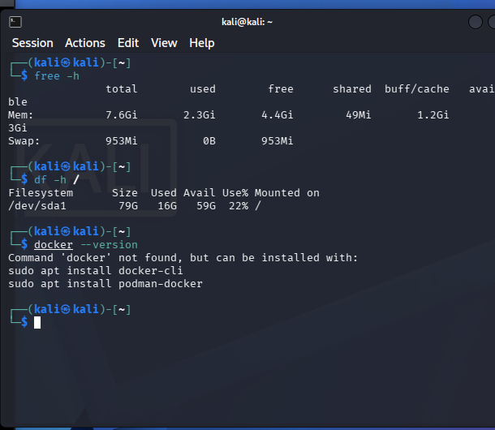
Figure: 1. Kali Linux Environment
Kali Linux was used as the lab environment for the cybersecurity activities. The terminal was used to run commands and manage the local tools needed for the exercises.

2. OWASP Juice Shop Running Locally
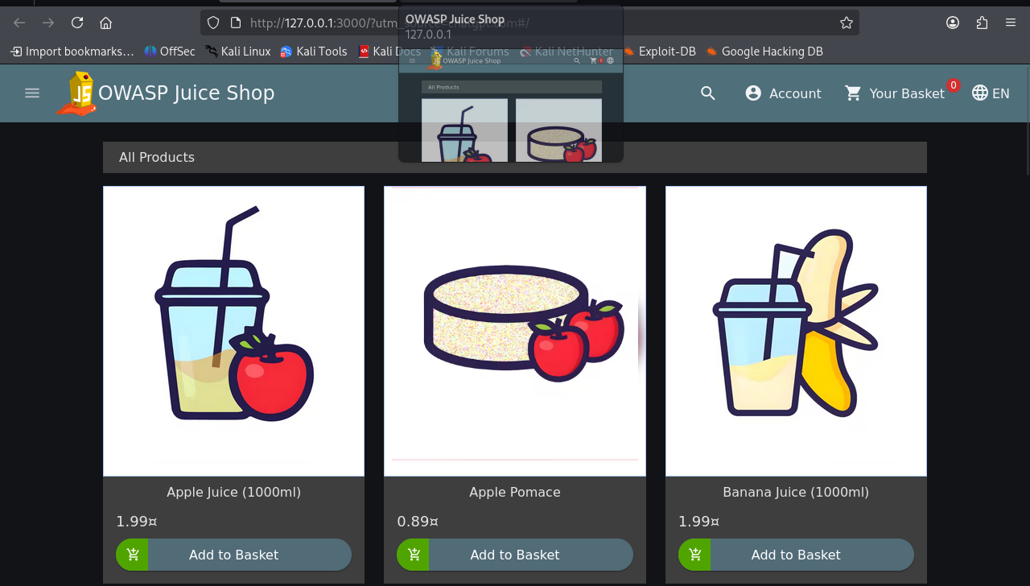
Figure: 2. OWASP Juice Shop Running Locally
OWASP Juice Shop was opened in the browser at http://127.0.0.1:3000. This is a deliberately vulnerable training application used to practise web application security in a controlled local lab.

3. Gobuster Command-Line Help
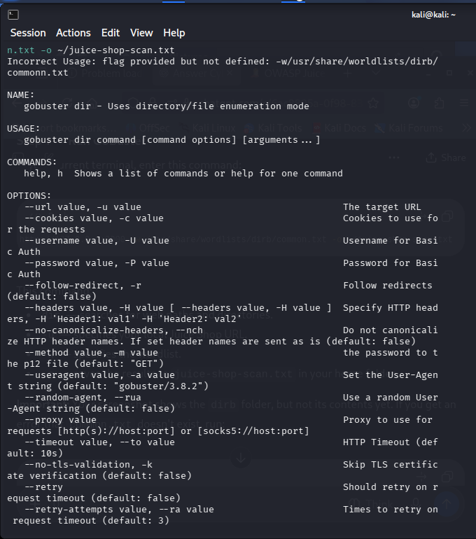
Figure: 3. Gobuster / Directory Enumeration
The terminal displayed Gobuster's usage information after a command was entered with an incorrect option. This helped identify the correct command structure before continuing. This screenshot does not show completed scan results.

4. Reviewing the Local Juice Shop FTP Directory
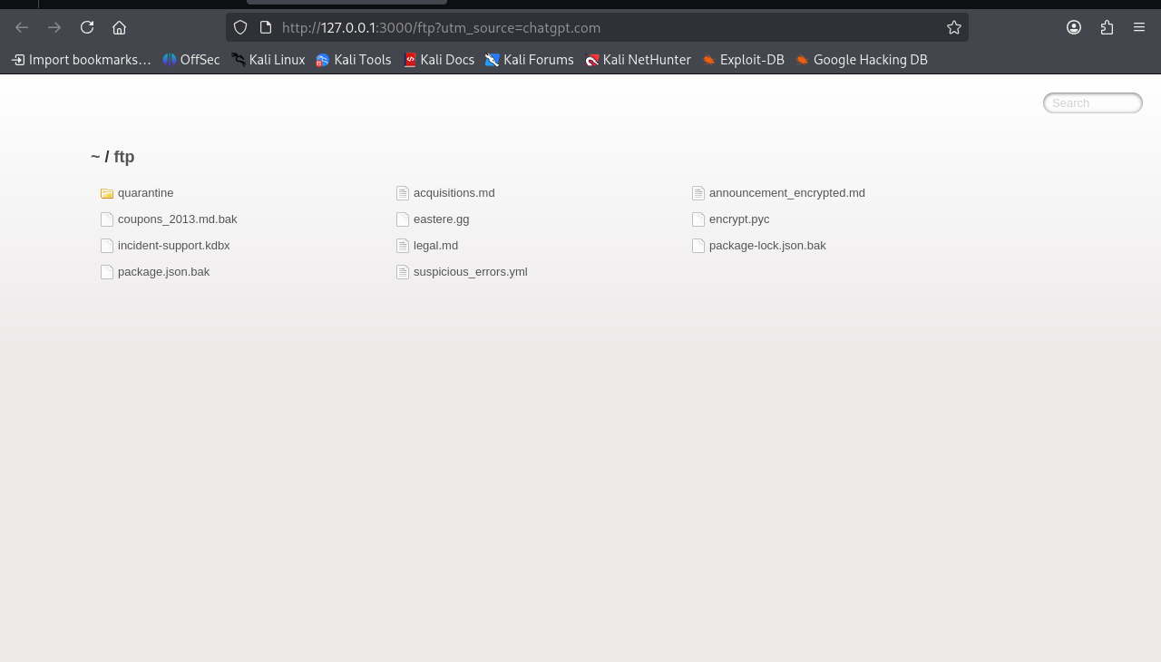
Figure: 4. Reviewing the Local Juice Shop FTP Directory
The /ftp path on the local Juice Shop instance was opened in the browser. The directory listing displayed example files and folders, demonstrating why exposed directories should be checked during an authorised web security assessment.

5. Inspecting a Downloaded File Safely
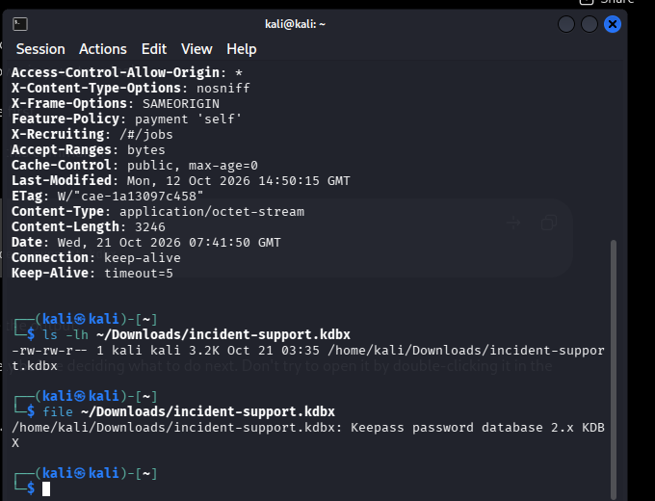
Figure: 5. Inspecting a Downloaded File Safely
The downloaded incident-support.kdbx file was checked using the Linux file command. The output identified it as a KeePass 2.x password database. The file was identified by type and was not opened or cracked.

6. OWASP Juice Shop Score Board
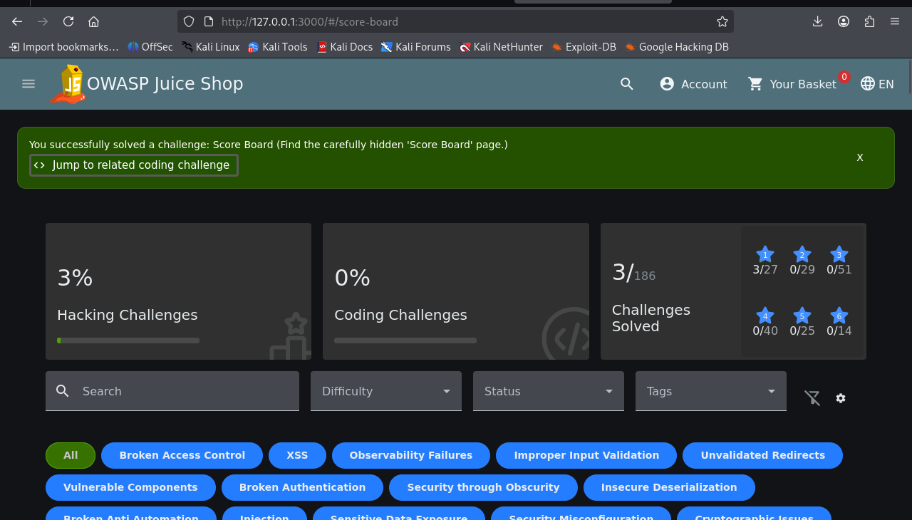
Figure: 6. OWASP Juice Shop Score Board
The Juice Shop Score Board was opened successfully. The page displayed the challenge progress and categories. This screenshot records progress in the intentionally vulnerable training application.

7. OWASP Juice Shop Challenge List
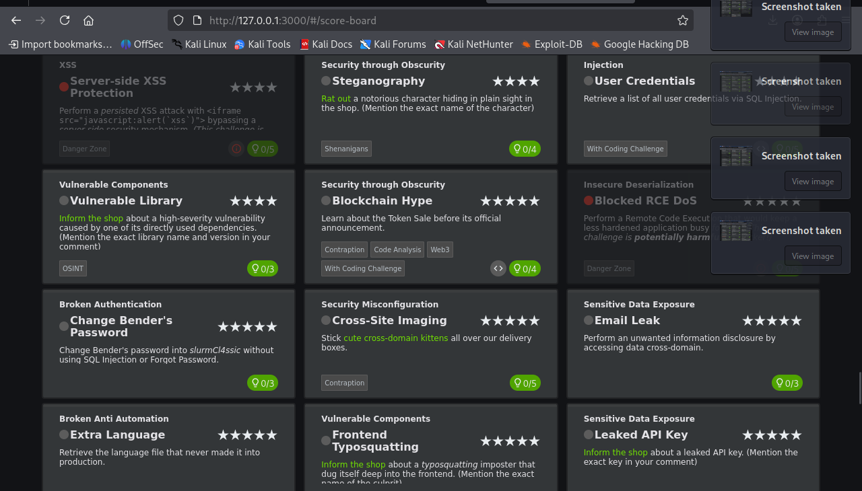
Figure: 7. OWASP Juice Shop Challenge List
The challenge list was reviewed to see available exercises and their categories, including broken access control, sensitive data exposure, XSS, and security misconfiguration. These challenges can be completed one at a time in the local lab.

8. GoPhish Dashboard
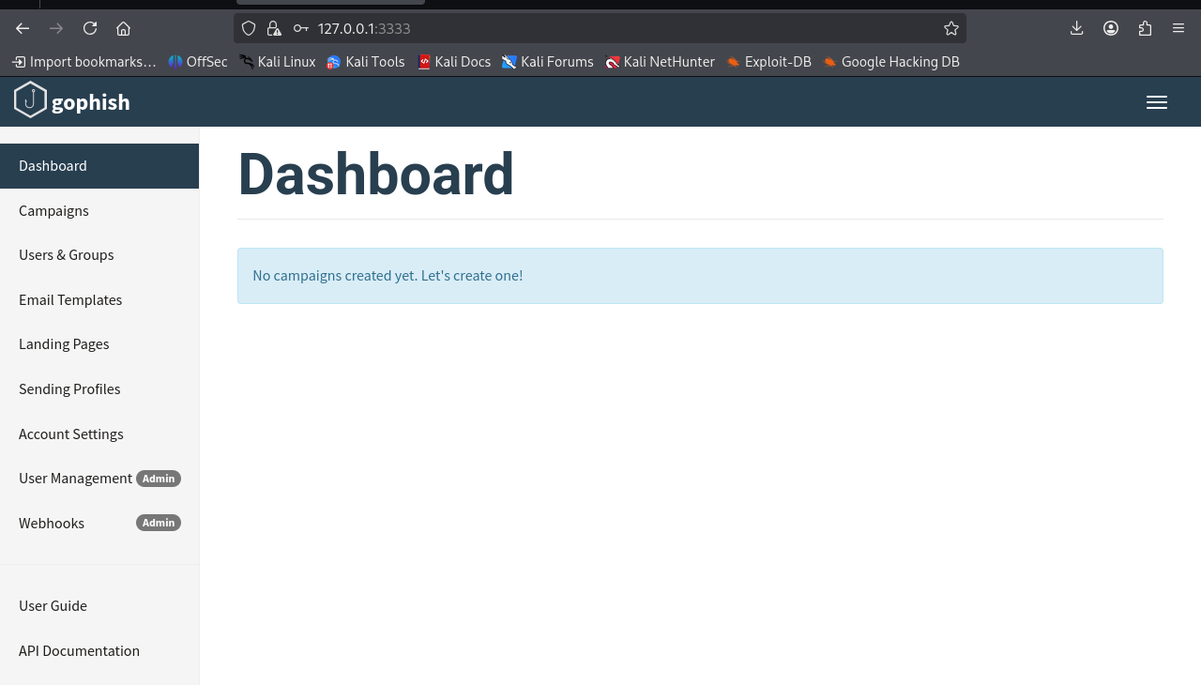
Figure: 8. GoPhish Dashboard
GoPhish was started successfully and its local administrative dashboard was accessed at https://127.0.0.1:3333. GoPhish is used for authorised phishing-awareness simulations. No campaign was created or sent in this screenshot.

Summary
These activities introduced a controlled web-security lab workflow: using Kali Linux as the working environment, accessing OWASP Juice Shop locally, checking paths with Gobuster and a wordlist, reviewing an example exposed-file listing, and opening GoPhish for awareness-simulation administration. The Gobuster results should be interpreted carefully because identical HTTP status codes and response sizes can indicate a fallback page rather than a real resource.
Scope and safety: All web testing documented here was directed at the local training instance (127.0.0.1:3000). GoPhish should only be used for simulations that have been approved by the instructor and participants.

